MODEL-of-the-MONTH
August 2017
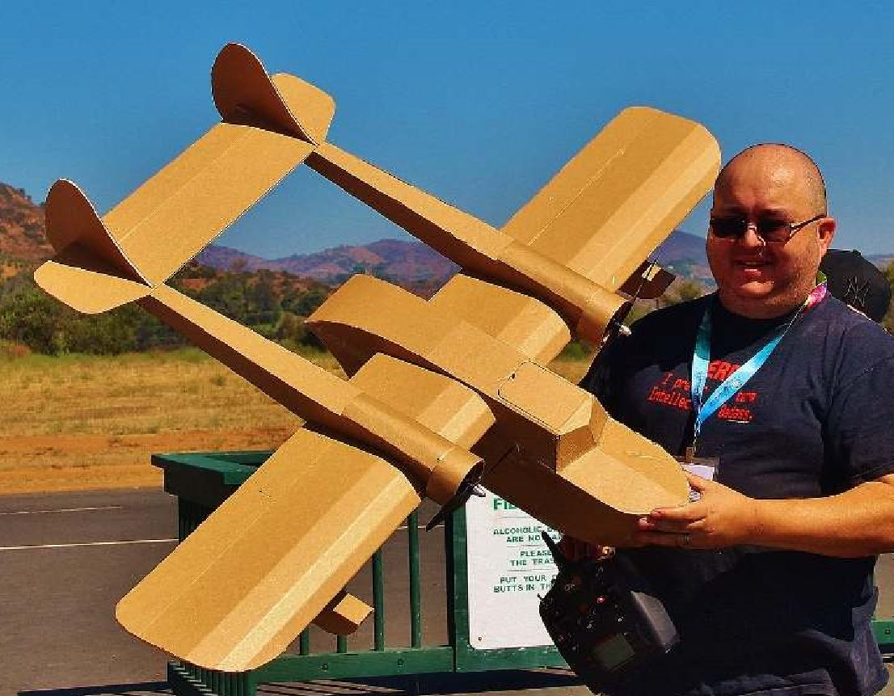
New member Doug Abel built this plane as his first build.
Statistics
Wing Span: 56 inches
Length: 42 inches
Weight: 2.45 lbs (without battery)
Power System: Twin Emax GT2215/09 motors with an Emax 30A ESC for each motor. Each motor is counter rotating and powered by a 2200 mAh 3S, 25C battery offering approx. 6 min. of flight time.
Prop Size: Currently running 10 x 4.7 props
Kitted/ARF by: Kit available through FliteTest.com, as the FT Sea Duck.
Mods to Kit/ARF: The only mods I have made are that I glued in some rare earth magnets on the battery door, and taped some pieces of razor blades to the top of the door to help keep it closed, rather than using tape.

