MODEL-of-the-MONTH
September 2017
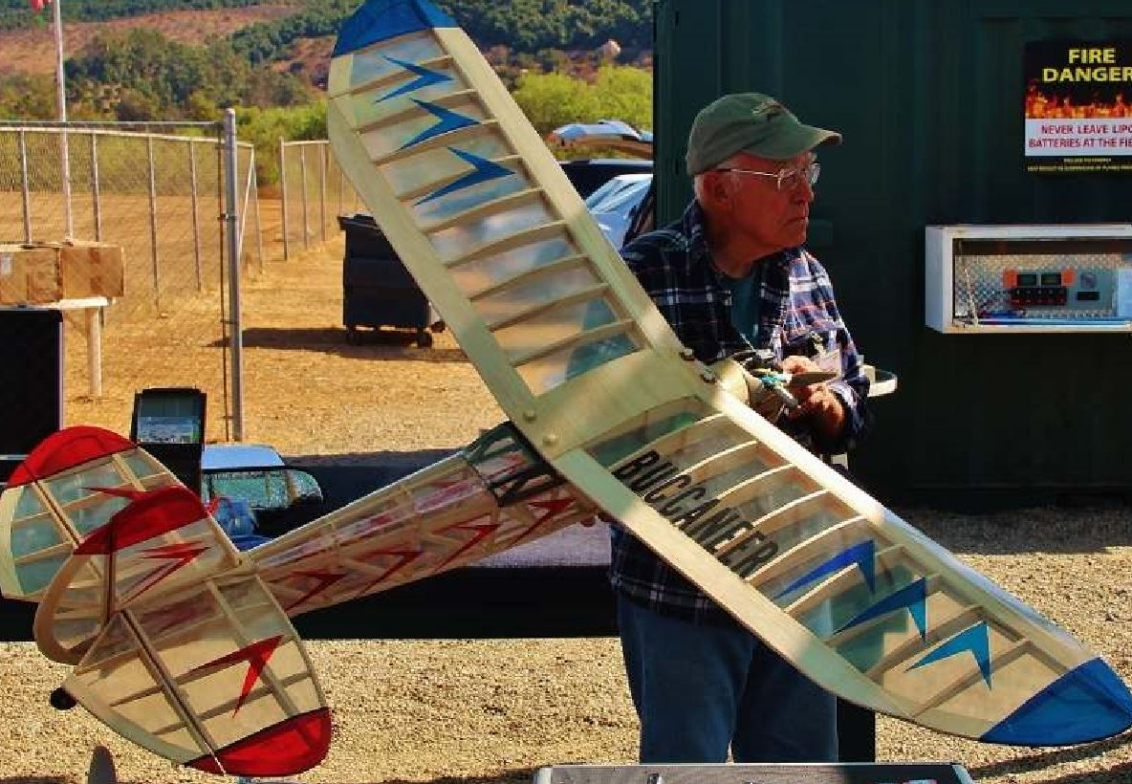
Master builder/re-builder/downed aircraft locator and recovery expert Roger Cosio won the Model of the Month with his new “Buccaneer” free-flight conversion.
Statistics
Wing Span:
Length:
Weight:
Power System:
Prop Size:
Kitted/ARF by:
Mods to Kit/ARF:

